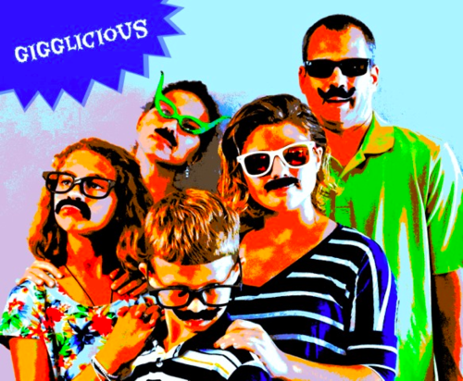

The Business of Inventing Toys with Kids

I asked some kids to think up something new for an oven that has nothing to do with regular baking and cooking…

Some of the answers I received were:

“The oven could walk across the room and give you your dinner.”

“It could have transformer arms that could open the oven door and take the food out when it was done.”

Completely magical. Completely inventive. Children aren’t constrained by the same reality that professional designers and inventors are. They don’t think about cost, manufacturability, or even the laws of physics. This is what makes them so interesting, creative, and one of the most important keys to my business.

My husband is my business partner and together we own Gigglicious, a product development and toy & game invention company. We have three vice presidents in our team. They are 16, 12, and 9 years old, and just so happen to be our kids.

To date, each of them have licensed at least one item under the Gigglicious name that has been sold in mass market stores. Gigglicious is - without question - a family business, and our kids are one of our most valuable assets. They test prototypes for us, star in our presentation videos, innovate, and design with us.

Once we have a category we’d like to ideate on (a kids’ party game or a swimming pool toy, for example), we sit down and dream up ideas together. Brainstorming with children is simple because they are bursting with good ideas once you get them started.

Here’s how we set up our inventing sessions with them:

SET A DATE AND TIME

Our family is busy, so we schedule time with our kids to brainstorm. We let them know which category we will be thinking on and what time we plan to meet. Usually we talk ahead of time about a few ideas so they can already have some thoughts together before we even sit down together.

SET THE MOOD FOR THEM TO CREATE

I put out crayons, colored markers, stencils, rulers, pencils and a ream of blank paper. Embarrassingly, before we start, I always crank up the song “Brainstorming” from Disney’s Imagination Movers and lip sync and dance to the whole thing just to make everyone laugh and get in the right mood. That has become tradition, and it’s my way of letting everyone know this is all for fun.

RULES

Before we get started, I always refresh everyone’s memory on our basic rules:

There are no bad or silly ideas.
You can’t say something bad about someone else’s idea.
Even a crazy idea can lead someone else down the road to a GREAT idea, and it usually does.
Include your name, working product title, and the date on the top of each piece of paper so you can credit the right person if the idea sells.
Once you have an idea roughly drawn on paper, clearly explain what it does to everyone. (This helps them flesh out the idea as they are talking.)
Don’t forget to stop drawing and listen. It can inspire more ideas.
PROMPTS

I put things out on the table to encourage thinking. For example, if we were trying to come up with a new type of baby doll, I would print out images of old and new dolls. I’d go to the library get books on dolls or doll making for us to flip through. I’d bring out any dolls we have in the house. I also like to include random things on the table that have nothing to do with what we are working on to encourage new thinking.

Most importantly in the process, we ask our kids questions and prompt them as they are working. For example:

How would your best friend play with this?
What if we had to add something from a completely different type of toy?
How would the opposite gender play with it?
What if you could use magic? What could it do then?
What would the toy look like in the future?
TIME

We invent until we run out of ideas. Sometimes it’s a few minutes, sometimes it’s a couple of hours. We find that ordering takeout and eating dinner while we invent is a great motivator to stick around the table and design awhile longer.

Not every session is a winner, and we don’t put that expectation on it. We’ve had several occasions where no one could come up with any ideas and we just ended up enjoying dinner together instead.

The most important part of designing and inventing with our kids is that it is one more way for our family to spend quality time together. That’s the best part of the job.

- Annie Wolfinbarger

