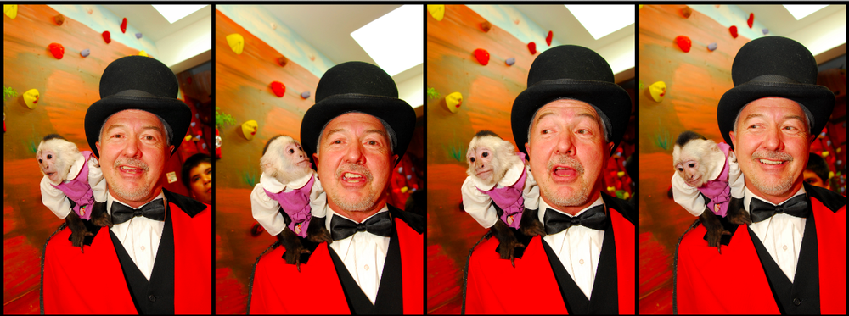

Inside tips for young inventors from one of the world’s top toy and game inventors, Bruce Lund.
NEVER, EVER, GIVE UP IN THE FACE OF A CHALLENGE." - BRUCE LUND
This summer, we had a chance to catch up with Bruce Lund of Lund & Company, who has been dreaming up hundreds of new inventions every year for over three decades. Bruce tells us how he first got started, shares tales of success (and one royal mess), and outlines 4 qualities every great toy inventor should have.

HOW DID YOU FIRST GET STARTED AS A TOY INVENTOR?

Try as I might, I couldn’t get a job as an industrial designer after graduating from Duke with a BS in Biology and from the Illinois Institute of Technology with a masters in design. Someone suggested to me that I try at Marvin Glass & Associates, the famed Chicago toy-invention studio, and I thought, “Why not? Who knows?” And I got the job.

WHAT WAS THE FIRST TOY YOU EVER INVENTED?

Fireball Island was one of the first games we successfully licensed to a company and had out on the market, though I worked on countless ideas before then that didn’t necessarily get anywhere.

I vividly recall as a young designer at the legendary Marvin Glass and Associates, I had created a top with a magic marker doo-hickey as the ‘point’ of the top. As the top spun it created spiraling patterns on paper. Quite cool. That would have been back around 1980, long before Doodle Tops were even a twinkle in some marketer's eye.

It never happened before. I never thought it was gonna happen. But it did. The marker top was spinning so fast that it sprung a leak and sent ink flying out 360 degrees onto each and every one of the partners at Marvin Glass. Simultaneously all six men sprang back away from the table in shock, cursing and loudly expressing their dismay at the stains on their similarly ink-besmattered, expensive, handmade-in-Hong-Kong bespoke shirts. After looking down at the fronts of their stained shirts, they all looked at me. I thought I was finished. I gathered up my marker top and slunk from the room. We never showed that toy to anyone, ever.

WHAT IS THE BEST THING ABOUT YOUR JOB?

No matter how many years I’ve been in the business, there are always new ideas and technologies to explore, if you just open your eyes and look around. It never gets boring.

WHAT IS THE INVENTION YOU ARE MOST PROUD OF?

Our Hydrogen Fuel Rocket, manufactured by Estes-Cox Corporation, was the first hydrogen-powered consumer product ever to hit the market. This was a groundbreaking new application for hydrogen power, not to mention a green technology, enabling anyone to launch a rocket right at home with great power, again and again.

WHEN YOU STARTED WORKING ON TICKLE ME ELMO, DID YOU KNOW IT WAS GOING TO BE SUCH A HUGE SUCCESS?

Everyone knew that the original Tickle Me Elmo, from 2006, was a game-changer. When we started working on our TMX, the 10th anniversary edition of that classic toy, no one had any idea how huge it would be.

DID ANYONE "POO POO" ON YOUR IDEA FOR DOGGIE DOO ALONG THE WAY?

They did. For 15 years or more they laughed at us every time we pulled that dog out of our vault and tried to sell it. Clients looked at me like I was insane. A pooping dog? Are you crazy? Yes, we are crazy. And we’re almost always right!

HOW DO YOU KNOW IF AN IDEA IS A "KEEPER" OR NOT?

You don’t always know. Sometimes it’s impossible to know. But then again, sometimes there’s an idea that you latch onto, and you just can’t seem to get it out of your head. If you’re still thinking about it 6 months later, 1 year later, 2 years later, then you’ve probably got something.

HAVE YOUR KIDS HELPED YOU MAKE ANY OF YOUR TOYS?

Yes, they have provided invaluable insight on many of the items currently in the Lund Vaults.

WHAT ARE SOME OF YOUR FAVORITE TOYS (NOW AND WHEN YOU WERE A KID)?

Trucks and explosives. Rockets, fireworks. Anything loud that could potentially hurt me, I couldn’t stay away from.

WHAT DO YOU THINK MAKES A GREAT TOY?

A great toy gives you an immediate gut reaction. You feel it without thinking about it. You come back to it again and again. You play with it over and over, for hours.

ARE THERE ANY IMPORTANT TRAITS YOU THINK EVERY GREAT TOY INVENTOR SHOULD HAVE?

First and foremost, the willingness to try anything. Secondly, a thick skin. In this business, you have to learn to love the word “no”. You also need a willingness to collaborate - any idea can be improved through sharing it and heeding feedback from others. Lastly, persistence. Never, ever give up in the face of a challenge.

COULD YOU TELL US WHAT THE USUAL STEPS OF YOUR INVENTION PROCESS LOOK LIKE, FROM GETTING AN IDEA THROUGH TO GETTING A TOY ON THE SHELF?

Make something. Just build it. Then modify it, improve it, tinker with it, then show it around and get feedback. Then improve it even further. Then move on to the next idea.

ANY OTHER TIPS FOR YOUNG INVENTORS WHO ARE JUST STARTING OUT?

Again, just build it. Learn to love the word ‘no’, you’re going to hear it over and over again. Instead of letting it discourage you, let it egg you on to do more, make more, and show your ideas to more people. Don’t stop at one idea. Come up with hundreds. Your ideas will get better over time, your process will get better over time, and you will learn more with each idea you bring to life.

